**Journal Entry: “Held by the Land, Sung to by the Thrush”** **1. Sensory Observation / Field Notes**

A late evening soundscape at our homestead garden on June 6, 2025, just after 10:00 pm. While outside planting lupines and aster in the garden bed my partner, Boyce, built earlier that day, I listened to the many sounds around me. A hermit thrush called from the northeast, while further in the distance I heard a robin and the soft quack of a pie bird (duck). Boyce and I exchanged only a few words as we kneeled in the soil, our quiet movements blending with the birdsong. Very faintly, intermittently, cars crossed the Goose River Bridge — a hollow, mechanical reverberation far away

**2. Embodied Response**

*During.* I felt still, grounded, and present. The canopy of trees in bloom, paired with the sharp, melodic tones of birds singing from different locations, created the sensation of being enveloped and held by the surrounding Land. The soundscape framed me in space, almost as though I were inside it rather than outside looking in.

*After.* When I came indoors, I reflected on how we begin hearing before birth — how infants attune to maternal voices and mother-tongue sounds in utero, associating them with comfort and safety. Developmental psychology describes this as the early “undifferentiated self,” a stage that reminds us listening is first relational, not individual — a point with resonance for how clients may experience sound. In this soundscape, I felt something parallel: a not-yet-separate-from selfhood. Listening felt like being both held and enclosed by nature. The sense of peace and groundedness mirrored maternal attunement — a reminder that sound, from our earliest moments, roots us in relationship and belonging. These reflections reminded me that listening begins in utero, shaped by relational sounds of safety — an important consideration when we think about how clients relate to sound.

While outside, there was an intuitive sense of not being alone — of being witnessed, not only by birds, trees, and my partner, but also by something older and deeply knowing. The Land itself felt like a participant in communion, a co-regulator.

# 3. Creative Interpretation

|  |
| --- |
| pasted-image.pdf  Figure 6 *Creative sound-map sketch representing my embodied experience of the soundscape.* The interpretation is meant to convey the sensation of being held, or enveloped within the soundscape, like a child in the womb. A blending of auditory and visuospatial perception in my mind’s eye. |

# 4. Scientific Representation

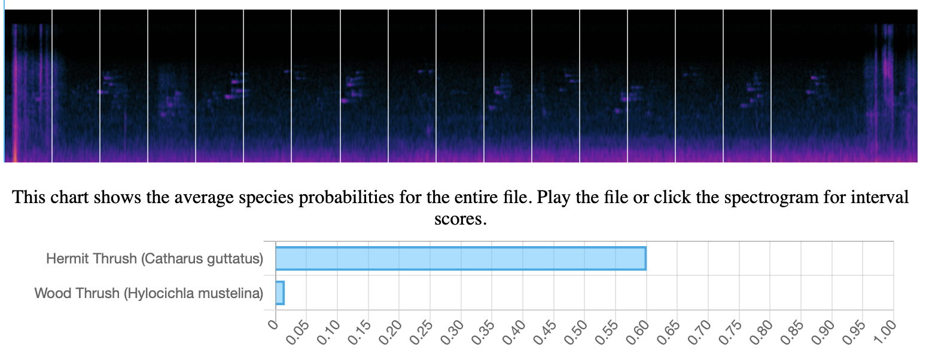

Figure 7 *Spectrogram analysis of audio recorded in our garden area.*Birds detected by BirdNET included hermit thrush (*Catharus guttatus*) and wood thrush (*Hylocichla mustelina*), complementing my own field notes of hermit thrush, robin, and pie bird. The spectrogram provides a measurable glimpse into the soundscape, complementing embodied and sensory reflections. In this way, the scientific lens does not replace lived experience but stands alongside it — part of a *Two-Eyed Seeing* approach that values both measurable data and relational knowing**.**

# 5. Self-in-Relation

# Finally, I reflected on how this soundscape connects to personal memory, family life, and evolving identity. The sounds recalled the first spring at our homestead, when our daughter Sibyl was a newborn. Nursing her in the sunroom, I listened to birds calling from the birch and black spruce — sounds that helped me feel at home in a new body and a new place. Birds became companions, greeting me tenderly during walks around the sandy cottage roads.

# In the present, kneeling low in the soil with Boyce, the layered sound of bird calls and soil patting felt like shared participation, not backdrop. The hermit thrush in particular resonated: distant yet enveloping, its song acknowledged our presence. Listening felt like practicing reciprocity — being in dialogue with Land as co-participant rather than observer.

# These moments brought me into quiet recognition of identity as both mother and clinician-researcher, situated in cycles that are ecological and ancestral. The thrush’s flute-like call, Boyce’s favourite bird song, echoed continuity and renewal — seasonal, familial, and cultural. This suggests how clients might also experience sound not just as input, but as connection — a framing with potential therapeutic implications. In this layered experience of listening — at once scientific and spiritual, embodied and ecological — I sense myself finding a way toward Two-Eyed Seeing: holding Western and Indigenous ways of knowing side-by-side, and allowing both to guide how I listen, learn, and belong in place.

# 6. Audio Record Log

|  |
| --- |
| sound_journal_qr_dropbox.png |
| ***Figure 8*** *QR code linking to audio recording taken in the garden area.* This QR code directs to the original sound recording associated with Journal Entry 1. It allows for direct auditory engagement with the soundscape described in the sensory, embodied, and scientific reflections.  Note. If the QR code does not work, the audio recording can also be accessed via direct file link upon request. |